**Types of Heating Systems 1**

**Central Heat**

**Furnaces**

The majority of North American households depend on a central furnace to provide heat. A furnace works by blowing heated air through ducts that deliver the warm air to rooms throughout the house via air registers or grills. This type of heating system is called a ducted warm-air or forced warm-air distribution system. It can be powered by electricity, natural gas, or fuel oil.

Inside a gas- or oil-fired furnace, the fuel is mixed with air and burned. The flames heat a metal heat exchanger where the heat is transferred to air. Air is pushed through the heat exchanger by the “air handler’s” furnace fan and then forced through the ductwork downstream of the heat exchanger. At the furnace, combustion products are vented out of the building through a flue pipe. Older “atmospheric” furnaces vented directly to the atmosphere, and wasted about 30% of the fuel energy just to keep the exhaust hot enough to safely rise through the chimney. Current minimum-efficiency furnaces reduce this waste substantially by using an “inducer” fan to pull the exhaust gases through the heat exchanger and induce draft in the chimney. “Condensing” furnaces are designed to reclaim much of this escaping heat by cooling exhaust gases well below 140°F, where water vapor in the exhaust condenses into water. This is the primary feature of a high-efficiency furnace (or boiler). These typically vent through a sidewall with a plastic pipe.

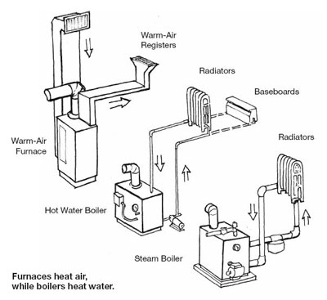

New furnace standards are currently under development by the U.S. Department of Energy, and are due to be finalized in the spring of 2016. The current furnace standards have not been updated since 1987.

Heating system controls regulate when the various components of the heating system turn on and off. The most important control from your standpoint is the thermostat, which turns the system — or at least the distribution system — on and off to keep you comfortable. A typical forced air system will have a single thermostat. But, there are other internal controls in a heating system, such as “high limit” switches that are part of an invisible but critical set of safety controls.

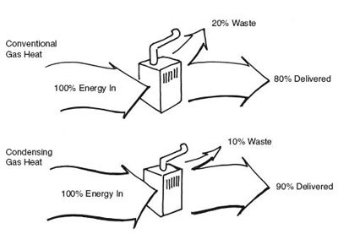

**The best gas furnaces and boilers today have efficiencies over 90%**

The efficiency of a fossil-fuel furnace or boiler is a measure of the amount of useful heat produced per unit of input energy (fuel). Combustion efficiency is the simplest measure; it is just the system’s efficiency while it is running. Combustion efficiency is like the miles per gallon your car gets cruising along at 55 miles per hour on the highway.

In the U.S., furnace efficiency is regulated by minimum AFUE (Annual Fuel Utilization Efficiency). AFUE estimates seasonal efficiency, averaging peak and part-load situations. AFUE accounts for start-up, cool-down, and other operating losses that occur in real operating conditions, and includes an estimate of electricity used by the air handler, inducer fan, and controls. AFUE is like your car mileage between fill-ups, including both highway driving and stop-and-go traffic. The higher the AFUE, the more efficient the furnace or boiler.

**Boilers**

Boilers are special-purpose water heaters. While furnaces carry heat in warm air, boiler systems distribute the heat in hot water, which gives up heat as it passes through radiators or other devices in rooms throughout the house. The cooler water then returns to the boiler to be reheated. Hot water systems are often called hydronic systems. Residential boilers generally use natural gas or heating oil for fuel.

In steam boilers, which are much less common in homes today, the water is boiled and steam carries heat through the house, condensing to water in the radiators as it cools. Oil and natural gas are commonly used.

Instead of a fan and duct system, a boiler uses a pump to circulate hot water through pipes to radiators. Some hot water systems circulate water through plastic tubing in the floor, a system called radiant floor heating (see “State of the Art Heating”). Important boiler controls include thermostats, aquastats, and valves that regulate circulation and water temperature. Although the cost is not trivial, it is generally much easier to install “zone” thermostats and controls for individual rooms with a hydronic system than with forced air. Some controls are standard features in new boilers, while others can be added on to save energy (see the “Modifications by Heating System Technicians” section on the [heating maintenance page](https://smarterhouse.org/content/maintenance)).

As with furnaces, condensing gas-fired boilers are relatively common, and significantly more efficient than non-condensing boilers (unless very sophisticated controls are employed). Oil-fired condensing boilers are uncommon in the U.S. for several reasons related to lower latent heat potential, and potential for greater fouling with conventional fuel oil.

**Heat Pumps**

Heat pumps are just two-way air conditioners (see detailed description in the [cooling systems](https://smarterhouse.org/content/types-cooling-systems-0) section). During the summer, an air conditioner works by moving heat from the relatively cool indoors to the relatively warm outside. In winter, the heat pump reverses this trick, scavenging heat from the cold outdoors with the help of an electrical system, and discharging that heat inside the house. Almost all heat pumps use forced warm-air delivery systems to move heated air throughout the house.

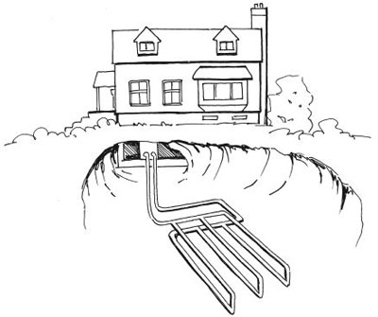

**A ground-source heat pump heats and cools in any climate by exchanging heat with the ground, which has a more constant temperature.**

There are two relatively common types of heat pumps. Air-source heat pumps use the outside air as the heat source in winter and heat sink in summer. Ground-source (also called geothermal, GeoExchange, or GX) heat pumps get their heat from underground, where temperatures are more constant year-round. Air-source heat pumps are far more common than ground-source heat pumps because they are cheaper and easier to install. Ground-source heat pumps, however, are much more efficient, and are frequently chosen by consumers who plan to remain in the same house for a long time, or have a strong desire to live more sustainably. How to determine whether a heat pump makes sense in your climate is discussed further under “Fuel Options.”

Whereas an air-source heat pump is installed much like a central air conditioner, ground-source heat pumps require that a “loop” be buried in the ground, usually in long, shallow (3–6' deep) trenches or in one or more vertical boreholes. The particular method used will depend on the experience of the installer, the size of your lot, the subsoil, and the landscape. Alternatively, some systems draw in groundwater and pass it through the heat exchanger instead of using a refrigerant. The groundwater is then returned to the aquifer.

Because electricity in a heat pump is used to move heat rather than to generate it, the heat pump can deliver more energy than it consumes. The ratio of delivered heating energy to consumed energy is called the coefficient of performance, or COP, with typical values ranging from 1.5 to 3.5. This is a “steady-state” measure and not directly comparable to the heating season performance factor (HSPF), a seasonal measure mandated for rating the heating efficiency of air-source heat pumps. Converting between the measures is not straightforward, but ground-source units are generally more efficient than air-source heat pumps.